Cloud-Based SMS

✅ What is Cloud-Based SMS?
# Source: AI Source: Provided by: [Data Path: Persons Table -> ID Column: 1, Name_En Column: Motasem Essam] -> From: [Chatgpt (GPT‑5 Mini)] on [1/21/2026]
Cloud-based SMS refers to sending and receiving text messages through a cloud-hosted platform, rather than using physical on-premise hardware like GSM modems or SMS servers.
These platforms are accessed via internet-based APIs provided by SMS service providers like:
- Twilio
- Nexmo (Vonage)
- MessageBird
- Plivo

🔧 How It Works:
# Source: AI Source: Provided by: [Data Path: Persons Table -> ID Column: 1, Name_En Column: Motasem Essam] -> From: [Chatgpt (GPT‑5 Mini)] on [1/21/2026]
- Your application (web/mobile/backend) calls the provider's SMS API.
- The provider routes the message through operator networks worldwide.
- The SMS is delivered to the end-user’s mobile phone.

📦 Key Features:
# Source: AI Source: Provided by: [Data Path: Persons Table -> ID Column: 1, Name_En Column: Motasem Essam] -> From: [Chatgpt (GPT‑5 Mini)] on [1/21/2026]
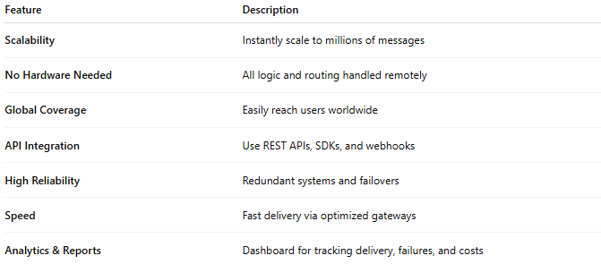

Feature | Description
Scalability | Instantly scale to millions of messages
No Hardware Needed | All logic and routing handled remotely
Global Coverage | Easily reach users worldwide
API Integration | Use REST APIs, SDKs, and webhooks
High Reliability | Redundant systems and failovers
Speed | Fast delivery via optimized gateways
Analytics & Reports | Dashboard for tracking delivery, failures, and costs

🧠 Benefits:
# Source: AI Source: Provided by: [Data Path: Persons Table -> ID Column: 1, Name_En Column: Motasem Essam] -> From: [Chatgpt (GPT‑5 Mini)] on [1/21/2026]
- Easy to implement
- Lower cost upfront (no setup hardware)
- Faster go-to-market
- Multi-channel support (SMS, voice, WhatsApp, etc.)
- Secure & Compliant (often with GDPR, ISO, etc.)

🛠️ Common Use Cases:
# Source: AI Source: Provided by: [Data Path: Persons Table -> ID Column: 1, Name_En Column: Motasem Essam] -> From: [Chatgpt (GPT‑5 Mini)] on [1/21/2026]
- Sending OTPs (One-Time Passwords)
- Marketing and promotions
- Alerts and reminders
- 2FA (Two-Factor Authentication)
- Customer support notifications

🆚 Compared to Traditional SMS:
# Source: AI Source: Provided by: [Data Path: Persons Table -> ID Column: 1, Name_En Column: Motasem Essam] -> From: [Chatgpt (GPT‑5 Mini)] on [1/21/2026]
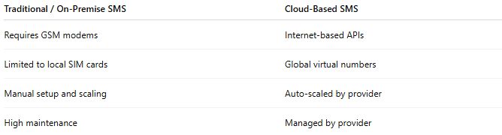
Traditional / On-Premise SMS | Cloud-Based SMS
Requires GSM modems | Internet-based APIs
Limited to local SIM cards | Global virtual numbers
Manual setup and scaling | Auto-scaled by provider
High maintenance | Managed by provider

